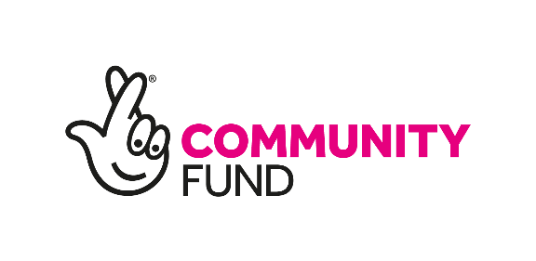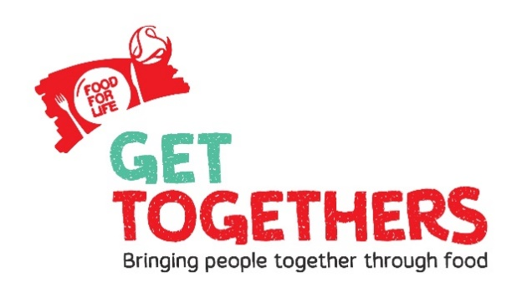

Food for Life, Food for Life Get Togethers
Small Grant Application Form & Guidance

June 2020 – April 2021

Grant Application Guidelines
Background
The Food for Life Get Together vision is a world where it’s normal for people of every age and every background to come closer together in their community, make new connections and be an active part in their local food system.
Food for Life is about making good food the easy choice for everyone – making healthy, tasty and sustainable meals the norm for all to enjoy, reconnecting people with where their food comes from, teaching them how it’s grown and cooked, and championing the importance of well-sourced ingredients. Rooted in partnerships schools, nurseries, community groups and organisations, Food for Life Get Togethers is for people of all ages and backgrounds.
Having the chance to get together and socialise whilst sharing fresh, healthy food or by growing or cooking food together can change people’s day to day lives for the better. We would like you to get involved by hosting Food for Life Get Togethers activities or gatherings in your community at any time of the year, or by holding a Food for Life Get Together as part of our national events if you want to be part of something bigger.
Due to Covid 19 you should adapt Get Together ideas you have to include current guidance on physical distancing or be innovative and take your Get Together online.
Food For Life Get Togethers can support you with free on-line resources, training, help to run and record success of your Get Together or with matchmaking and connecting you to local people or groups. Please access support from your regional or national team.
Grant offer
We are offering small grants of £150 to enable you to host a good food Get Together in your community. The money can either be used for activity costs (for example, seeds, transport, technology, food etc.) or equipment (for example, induction hobs, fridges, durable gardening tools, etc.).
We invite applications that bring people of different backgrounds and/or ages together to strengthen and connect communities through one or more of food growing, cooking and food sharing.
Strong applications may also have a focus on one or more of the following:-
- Food activity that has potential to be long term and become a normal or regular thing your community does

- Activity that brings people, households, streets, neighbourhoods & communities together through food

- Food activity which includes people and groups from disadvantaged and diverse communities

- Food activity which tackles or reduces experience of loneliness or social isolation for younger and older people in your community

- Food activity which encourages people to have a more positive attitude to ageing and/or people from diverse backgrounds

- Food based activity that is created together with the people and communities who will benefit
All applicants must have registered their event online through our website before the application deadline.
Who can apply?
The grant is open to not-for-profit groups and settings including, but not limited to; local community groups, nurseries, schools, care homes, community health and social care settings, housing associations, charities. Community groups must have a bank account in the group’s name. Food for Life Get Togethers should be representative of diverse communities, so you will need to consider this when planning your activity or gathering and when applying for the grant.
*If you want to have a Get Together with people from households or your neighbourhood you will need to apply for the grant through a formalised not-for-profit group that has its own bank account.
The number of grants is limited and due to the number of applications we may receive, we reserve the right to close the application round early.
There will be a focus on awarding grants to groups and organisations in the Food for Life Get Togethers ‘test and learn regions’ who may experience social and economic disadvantage. A map of eligible areas is shown in the terms and conditions section of this document.

Timeline
You can send your application at any time and we will review it following the deadlines specified in the timeline below. Some grant funding rounds are also aimed to support engagement with Food For Life and our partner’s national activity or events. Please ensure you apply in enough time to receive payment before your Get Together good food activity or gathering. Applications close for each round at 5.30pm on the deadline day.
2020 | Application Deadline | Payment Date | Can support, but not limited to
Round 1 | Friday 10th July | Friday 24th July | Summer focused
Round 2 | Friday 11th Sept | Friday 25th Sept | World Food Day
Round 3 | Friday 13th November | Friday 27th Nov | Christmas focus
2021
Round 4 | Friday 12th Feb | Friday 26th Feb | Spring / growing
Round 5 | Friday 12th March | Friday 26th March | Grandparent Gardening Week
Round 6 | Friday 30th April | Friday 14th May | Big Lunch focus
*Please note: We reserve the right to review and change these dates accordingly.
**Please note some rounds can support Get Together National events (column 4) but are not limited to these purposes.
Financial arrangements
We will accept applications which support individuals to get involved. However, we cannot administer payments to an individual’s bank account. Payments must be paid to an ‘organisation’ that the individual is a member of/associated with/delivering a Food for Life Get Together activity or gathering. The organisation must also be ready to receive the grant into their bank account, manage distributing the grant to the individual and be willing to facilitate reporting on expenditure if required.
Please provide bank details in the form below that you would like the grant to be paid into. All bank details from unsuccessful applications will be destroyed shortly after the grant decision has been made.
Payments will be made on the set dates in the timeline. If you are applying for activity later in the year, payment will be made on the date closest to your application submission. Applications close for each round at 5.30pm on the deadline day.
Sending us your application
Use the form below to apply for a grant.
You will need to email your application to fflgtsmallgrants@foodforlife.org.uk
Please clearly specify in the email subject line ‘Small Grant Application’ and include the name of your organisation.
Due to COVID 19 with our Bristol office being closed, we cannot accept postal applications at this time.
How we will process your application
You will receive an email from us confirming that we have received your application. Application decisions are agreed by the Food for Life Get Together Steering Group and all decisions are final. We may ask you for further information. We aim to deal with all applications in a friendly and efficient manner, if we fall short of these aims, please let us know. If you do not hear from us that your application has been successful you can assume you were not awarded a grant. Unfortunately, we cannot provide feedback for unsuccessful grant applications.
Contact
If you have questions relating to the submission of your application please email them to fflgtsmallgrants@foodforlife.org.uk . Alternatively if you require any help in filling in the application form please contact your Regional Team who will be more than happy to assist – their details can be found on the website.

Grant Eligibility Form
All applicants must fill in this form (boxes will expand as you type).
All applicants must have registered their event on the website.
Personal Details
Name of organisation, group or setting applying:
Name of individual making application on behalf of the above:
Email address:
Phone Number:
Your website address/Facebook page/Twitter handle: (if you have one)
Grant round number you are applying in: (see timeline above):
Address where the Food for Life Get Together will be held ensuring you include the postcode. If the event is virtual or includes multiple postcodes, please state and list them where possible.
Which of the Food for Life Get Together test and learn areas are you based in?
The map in the guidance point 18 shows which areas are test and learn areas.
If your activity is online, please tell us the platform you will use e.g. Facebook, Zoom, YouTube and how you will deliver it e.g. virtual cook along.
Grant request
Is your grant for activity costs, equipment costs or both?
Get Together name and theme:
What date will your Get Together be held?
Have you registered your event online?  (please note that unless registered we will be unable to process your application). | Yes/No
How many people do you expect to benefit?
What is the duration activity?
(e.g. 2 hours, ½ day, 4 times over a month)
In no more than 500 words, please tell us:
Who you are?
e.g. community group, charity, school etc
What it is you are going to do?
e.g. a cook along, growing food, creating recipe packs etc

How are you going to do this?
e.g. virtually, delivery service, outdoor socially distanced event etc.

Who will benefit and how?
e.g. older people, families, vulnerable adults etc

How is good food included in your activity? e.g. a focus on growing foods, choosing healthy and accessible recipes, using seasonal and local produce etc
What do you plan to do after this ‘Get Together’ to keep momentum going?
e.g. continue with a similar regular activity, extend your reach, commit to a regular event
Please list and give approximate costs of what you will spend the grant on if successful: e.g. food containers, seeds, room hire etc.
Communications and Marketing
Would you be willing for us to share your experience of receiving a grant through our website or social media? | Yes/No
May we add your contacts to our Get Togethers newsletter? | Yes/No
If you are successful can we contact you in the future to hear the story of your Get Together for our evaluation? | Yes/No
Is this the first time you’ve applied for a small grant with FFL Get Togethers? | Yes/No
Please tell us where you heard about FFLGT. e.g. direct email, website, colleague etc.
Bank Details
Name and address of bank:
Name of account holder/organisation:
Account Number:
Sort Code:
Please note that the money will be sent from Soil Association Ltd which will appear on your bank transactions.
Thank you for your interest in applying for a small grant.
By signing below, you are agreeing to the grant terms and conditions and privacy notice.
Signed by: ……………………………………………………………………………………………..
Date: ………………………………………………………………………………………………………..
Please send your completed form to: fflgtsmallgrants@foodforlife.org.uk
Grant Terms and Conditions
- The grant may be used only for the purposes outlined by your organisation in your grant application as approved by the Food for Life Get Togethers Steering Group. We understand that activities sometimes change as they develop or may be cancelled. If you are unable to use the grant for the specific purpose for which it was intended and significant changes are likely to be made please contact us before spending any portion of the grant. Grants must be spent within 6 months of receipt.
- The grant cannot be transferred to another third party.
- We will decline any grant applications where there is no organisational or community group bank account to transfer the grant into.
- The grant is only for use for a Food for Life Get Together activity or gathering and should not be spent on anything else.
- We won't consider any applications which involve promoting any corporate organisation, political activities or promoting any religious beliefs. We will consider projects led by religious organisations if they're for the good of the whole community.

- We won’t consider projects that have already happened or will be finished before the grant payment can be made.
- The maximum amount you can apply for is £150.
- If you are successful, you will not be able to apply for another small grant in future years but partner organisations/settings that you are working with are able to apply. Please let us know if you need support on how to fundraise to help turn your get together into a regular activity. If you have previously received a small grant, you are unable to reapply.
- We expect that any press releases referencing the work funded be forwarded to the Food for Life Get Togethers Team.
- Any publicity of the grant funded activity must reference Food for Life Get Togethers and The National Lottery Community Fund.
- You agree that we can use any of the information and images you've given us in any of our publicity or marketing.
- We will be carrying out financial safeguarding checks on a sample of successful applicants. Therefore, we request the right to receive your proof of purchase in the form of receipts. We will expect to see receipts within 14 working days from the date requested.
- The Get Together organiser will be required to complete a short evaluation form. We may use your evaluation for reporting purposes or to publicise the grants. We may also ask you for updates after the project is over.
- We will require repayment of a grant if you become insolvent or go into administration, receivership or liquidation.
- If your organisation does not meet the requirements set out in this document, then we reserve the right to reclaim some, or all, of the grant at any time.
- The safety of everyone attending your Get Together is extremely important. Use your own organisation’s policies and procedures to ensure you think about the related risks, including the safeguarding of children or young people or adults at-risk attending your activity.
- Applications can be received from organisations outside of Test and Learn areas who are holding their event/activity within a Test and Learn area – please make this information clear on the application form.
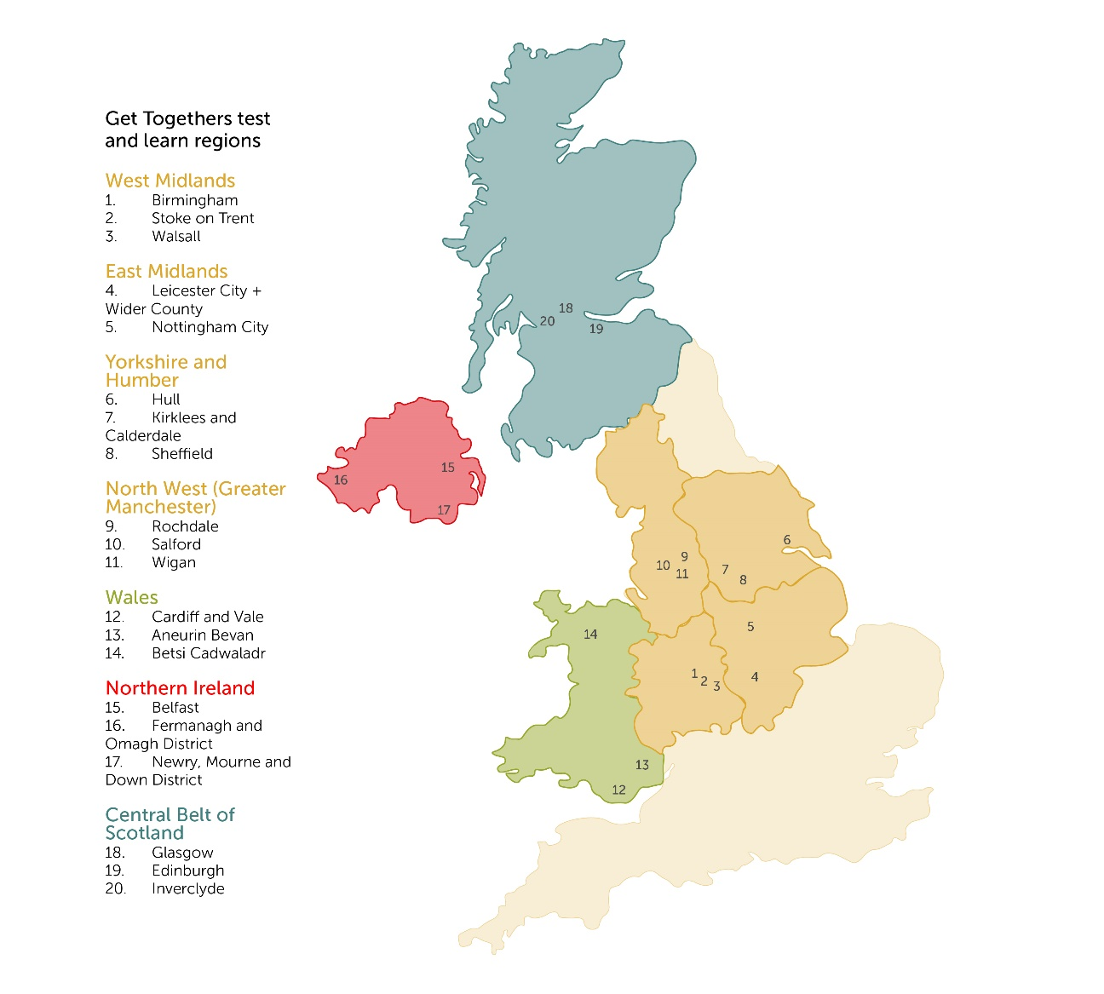
- Below is the map of the eligible areas for grant applications:

Health and Safety Considerations
- Ensure that you are always following the latest government COVID 19 guidelines. Country specific: England, Wales, Northern Ireland, Scotland.
- Ensure that you are always following the latest NHS COVID 19 guidelines and advice.
- If you have recently recruited new volunteers or utilising existing volunteers, please read and refer any volunteers to the Government’s ‘How to help safely’ guidance (Sections 1, 3 and 7 specifically). For more advice, visit the NVCO website.
- In any food related activity, you should follow the latest Food Standards Agency guidance.
- We ask that you don’t promote or give any medical advice.
- For advice on GDPR and data protection during your response, please see the section ‘Data Protection’ on the NVCO website to minimise risk.
Privacy Notice
1. As part of the requirements of The National Lottery Community Fund, Food for Life Get Togethers is required to keep any information for 7 years. An extract of this retention policy is available on request. Unsuccessful applicant’s bank detail information will be destroyed, as well as successful applicants bank details once payment is made – although a record of payment will be held by Soil Association Accounts team.
2. We may share your details with others internally working for Food for Life Get Togethers who help us assess, manage and process your grant application.
3. You will be added onto our database so we can access your contact details and send you future and marketing updates, e.g. FFLGT monthly e-newsletter.
4. We may contact you for future communication, marketing and evaluation opportunities, for example a case study on what you did with your grant if successful.
If you have any worries, complaints or want to OPT OUT in regards to the way we will use your information, please don’t hesitate to get in touch with us.

